The Valleys Evangelical Covenant Church
Rev. David Guertin, Pastor
Hymnal Technician: Bridget Campbell
Choir Director, Ed Dobbin
Acolyte, Cailey Crum
April 15, 2018 - Worship, 10:15AM
“Strong in the Word to Serve in the World”

(*Indicates: Stand as you are able.)
Hymns are in the (RED) HYMNAL for Worship & Celebration

Chimes
Greetings and Announcements Charles Cichy
* Call to Worship: (Responsively)
L: Come, let all of God’s people give praise and worship the Lord!
P: For we were once lost and without hope before the Lord God Almighty.
L: On the cross the price was paid for our sins for all who accept Christ.
P: In Christ we are washed clean before God of stains we could not remove.
L: Then let us celebrate and give praise and lift our voices in joyful song.
ALL: Blessed be the name of the Lord!
L: Come, let us worship God!

Prelude (lighting of Altar Candles)

* Hymn - “Come, Christians, Join to Sing” Page 108
* Opening Prayer

(Please be seated)
Responsive Reading - Psalm 40:1-11 Page 803
(In BLUE COVENANT HYMNAL)

Affirmation of Faith: (In Unison)
We believe in God who created and is creating the world, who came to us in His Son, Jesus; To reconcile and save. Who works by His Spirit. Who calls us into His church to celebrate His presence, to join hands and hearts in service. To proclaim Jesus Christ - crucified and risen - our only hope, in life and in death, and unto the life everlasting. These things we believe in our hearts and will proclaim with our voices. Amen.

Hymn - “Nothing But the Blood” Page 195
Prayer cards will be collected during the 2nd hymn.

PRAYER / LORD’S PRAYER
Our Father, who art in heaven, Hallowed be thy Name. Thy kingdom come. Thy will be done, on earth as it is in heaven. Give us this day our daily bread. And forgive us our debts, as we forgive our debtors. And lead us not into temptation, but deliver us from evil. For thine is the kingdom, and the power, and the glory, for ever. Amen.

Choral Response - “Hear Our Prayer O Lord” Pg. 614

Gideon Presentation by Mr. Doug Walborn

Scripture - Hebrews 10:1-10 (Pg. 303 of NT Pew Bible)
Scott Miller, Lay Reader

Message- “A Priest Like No Other”

Offering Invitation
Offertory
* Offertory Response - “We Give Thee But Thine Own” Pg. 620
* Prayer of Dedication
* Hymn - “When I Survey the Wondrous Cross” Page 185
* Benediction
* Greeting: “The peace of God be with you.”
Response: “And also with you.”
* Passing of the Peace: Please greet those around you.
* Post-Service Music

We welcome Mr. Doug Walborn of The Gideons International this morning. There is a basket in the rear of the sanctuary for donations to support The Gideons ministry.

Welcome to Worship at the Valleys. We want to personally welcome all visitors. Please take time to sign your name and address in our guest book located in the foyer as you leave.

PLEASE TURN OFF CELL PHONES, PAGERS, ETC. during our worship service. Thank you for your cooperation.

FELLOWSHIP TIME FOLLOWING WORSHIP SERVICE is held on Sundays in the Multipurpose Room (Meeting room) with coffee, drinks and cookies. Please join us.

WORSHIP PARTICIPANTS
April Announcer  Dave Novinger | April Acolyte  Cailey Crum
Apr. Greeters  Sharon & Gary Fetterhoff,  Gary Snyder | Apr. Ushers (Team 4)  Diane Shaffer, Leon Shaffer, Carolyn Nye, Ken Bechtel

 | Apr. 15  Trad. | Apr. 22  Blended | Apr. 29  Trad. | May 6  Trad.
Lay Readers | Scott  Miller | Norine Goss | Arletta Thomas | Marie  Herb
Nursery Attendants | Neva  Cichy | Theresa  Miller | Patty Hummel | Ann  Hale
Adult Sun. School Teachers | Marie  Herb | Donna Novinger | Bob  Endy | Laurel  Guertin

*Please tell the Captain if you are unable to be present for a Sunday as the Captain will need to get someone to help with Usher duties. Please call the church office (717-896-3118) if you are unable to be Lay Reader or Nursery Attendant on your scheduled Sunday. Please tell Ken Bechtel if you cannot teach on your assigned Sunday.

9:00AM Sunday School Class Options:
Adult Class – Sanctuary Friends In Faith - Computer Room
Choices - Multi-purpose Room
Children & Youth - Nursery and S. S. Classrooms
Confirmation – Library

GIANT GIFT CARDS available to purchase (before/after church). Valleys receives $5 for every $100 Giant gift card purchased.

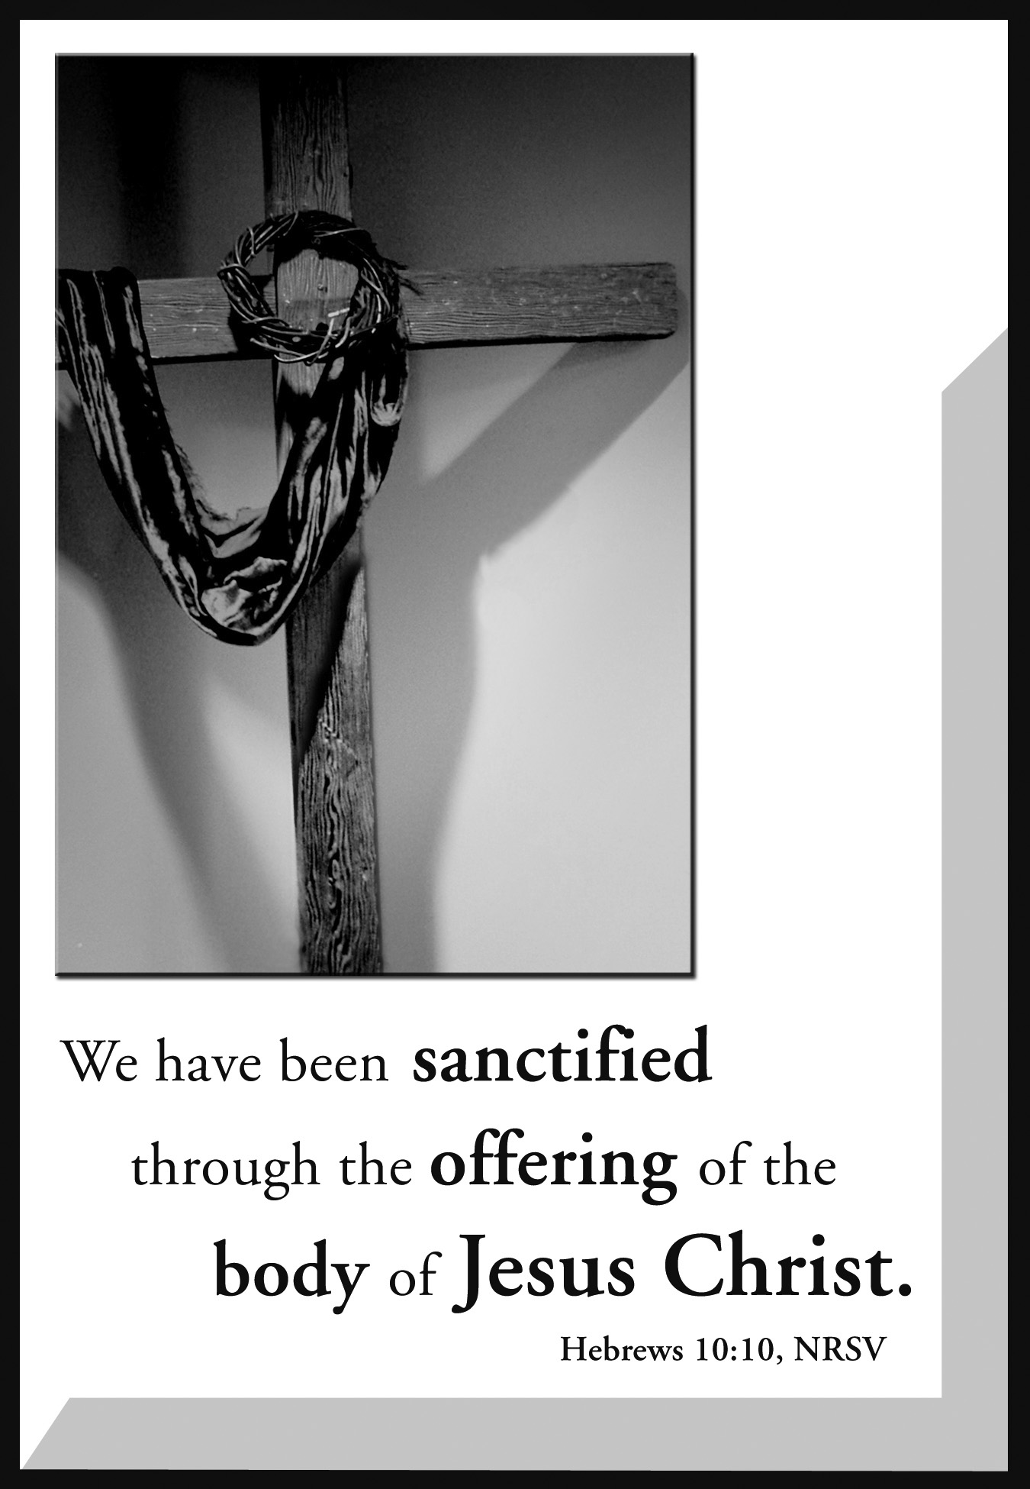

The Valleys
Evangelical Covenant Church
Halifax, PA

Pastor David Guertin
Office (717-896-3118), Cell (1-715-497-4310)
Email - daveguertin64@gmail.com

Church Office Hours: Mon. thru Fri. - 10AM to 3PM
Church Office (717-896-3118)
Web Site - ValleysEcc.Org Email - valleysecc@verizon.net

CHURCH CALENDAR
Apr. 15 - 9:00AM - Sunday School/Confirmation Class
10:15AM - Traditional Worship (Hymnal)
2:00PM - Zumba
Apr. 16 - 8:30AM-Noon - Halifax Senior Center open Mon.-Thurs
9:00AM - Yoga Exercise
10:00AM - Bible Study (April Ocaiso, Leader)
Apr. 17 - 6:00-8PM - G. S. Trps. 10738 & 10740
Apr. 18- 8:30-11AM - Senior Center (No Yoga)
Noon-3PM - Senior Center Pinochle Card Party
6:00-8PM - G. S. Trps 10573 & 10728
6:15PM - Zumba; 7:15PM - Zumba Burst
7:00PM - Council Meeting

Apr. 22 - 9:00AM - Sunday School/Confirmation Class
10:15AM - Blended Worship (Praise Team/Hymnal)
Mission Offering
1:00-5PM - G. S. Sister to Sister Event (No Zumba)
6:30PM - Youth Group

Pastor Dave will be on vacation Apr. 23 thru May 1 (he will be working at the ECC East Coast Conference annual Meeting
Apr. 25-28)

Apr. 23 - 6:00AM-1:00PM - Mr. Sticky Buns pick up
8:30AM-Noon - Halifax Senior Center open Mon.-Thurs
9:00AM - Yoga Exercise
10:00AM - Bible Study (April Ocaiso, Leader)
Apr. 24 6:00AM-1:00PM - Mr. Sticky Buns pick up
6:00-8PM - G. S. Trps. 10738 & 10740
Apr. 25 - 6:15PM - Zumba; 7:15PM - Zumba Burst
Apr. 26-27 - ECC East Coast Ministerium Association Meeting
Apr. 27-28 - ECC East Coast Conference Annual Meeting

Apr. 29 - 9:00AM - Sunday School/Confirmation Class
10:15AM - Traditional Worship (Hymnal)
2:00PM - Zumba

Praise Team meets on Thursday Apr. 19 at 6:30PM

*PRAYER REQUESTS* *(indicates new)
Please remember all the people on our Prayer List with prayers, thoughts, cards:
MEMBERS & FRIENDS OF THE VALLEYS:
*Pastor Dave Guertin; *Ken Zeigler, (Geisinger-Holy Spirit Hosp. Rm. 648); *Kevin Jones, (Pat Dobbin’s friend’s nephew); *Gail Shertzer, (Comm. Gen. Osteopathic Hosp. Rm. 529); *Amy Heintzelman-Reinfeld, (Harrisburg Hosp., friend of Carol Miller); *John Haine; Ritchie Moorhead; Tom Hale; Marissa Faust; Sandy Zimmerman; Nicole Shoop; Donna Motter; Miriam Hoke; June Gelnett; Betty Lebo; Charlie Enders; Tom Lauver; Jane Baker; Hannah Klinger; Esther Masser; Elmer Feidt; Randy Byerly; Edna Lenker; Mari Miller; Ben Baker; Donna, Sandy, Scott; Lillian Danner; Kelly Shutt; George Wert; Troy Millard; Jody Russel; David Roadcap; Henry Helfich; Lester Baker; Pat & Richard Snyder; Stephanie Schrieber; Dottie Rand; Liam Neiswender; Inez Boyer; Dexter Lucia,; Terry Etzweiler; David Ney; Andrew Klinger; Mike Hall, (Nicole Shoop’s father-in-law); Mick Sager; Joann Scull & Carl Baker; Gloria Hoffman; Mike Weller; Jo Spisak; Jason Mark, (Richard Hoke’s Friend & Co-worker); Edna Crum; Janet Helt; Joan Kent, (Hosp., Wanda Hendershot’s sister)

OUR SHUT INS: Myra Hoffman, June Wiest; Lori Graff; Marlin Erdman; Vickie Shoffler

MISSIONS: Covenant Missionaries: Jen and Minh Dao; Cathy Campobello; Covenant Missionaries and all Missionaries serving all around the world.
Please remember to inform The Valleys if you or a member of your family is in the hospital as the hospitals will not inform us unless you tell them to contact us. You may call the church office (896-3118) or Donna (717-362-8870) after office hours. ~~~~~~~~~~~~~~~~~~~~~~~~~~~~~~~~~~~~~~~~~~~~~~~~~~~~~~~~~~

LIFELINE PREGNANCY CARE CENTER 2018 BABY BOTTLE CAMPAIGN. (Please put your name and phone number on the tablet when you pick up the baby bottles(s). All baby bottles must be returned by May 13.
There is a large baby bottle for donations if you do not wish to take a small bottle home. Please see Marie Herb if you have questions.

NO CHOIR PRACTICE during April.

MR. STICKY BUNS will be at Valleys on Mon. Apr. 23 and Tues. Apr. 24 (6:00AM to 1:00PM). Order sheets are in the foyer or call Valleys church office (717-896-3118) to order. Bulk orders sheets should be returned by Mon. Apr. 16. If you take order sheets for bulk orders, please put your name and phone number and which order day on the yellow sheet. See Ed Berra if you have any questions.

EVANGELICAL COVENANT CHURCH EAST COAST CONFERENCE ANNUAL MEETING will be held at Bethany Covenant Church Berlin, Connecticut on April 27th & 28th. Pastor Dave Guertin and Dave Novinger will attend the conference as our delegates.
Pastor Dave will be on vacation Apr. 23 thru May 1 (Apr. 25 thru 28 Pastor Dave will be working at East Coast Annual Meeting.)

MOTHER’S DAY BREAKFAST will be held on Sunday, May 13th at 8:00AM. Bring your favorite lady (and the rest of the family) and enjoy breakfast and fellowship! (Men will put egg bake together at 9:00AM on Saturday May 12. See Dave Novinger if you wish to help.)

HALIFAX SENIOR CENTER is open 8:30AM-Noon Mon. thru Thurs. Senior Center is open at 8:30 to 10:00AM for anyone who wishes to play card games in the Multipurpose (meeting) Room.
April Monday Morning Bible Study Leader: April Ocaiso. Yoga exercise (on chairs) in library Mon.-Thurs. at 900AM in library (except the week of the card party or if the Senior Center is closed) - everyone is welcome!
Pinochle Card Party is on April 18 from Noon to 3:00PM.
Calendar is on Bulletin board in narthex.

Meals-on Wheels Drivers are needed! Contact Dave Kessler (717-576-1965) if you to wish to volunteer to deliver meals.

CHURCH ATTENDANCE for Apr. 8 – 67.

2018 GRADUATES: The Valleys ECC would like to congratulate our 2018 Graduates (also any graduates since last June) by recognizing them during the worship service on May 20, 2018. They will also be listed in the June newsletter. Please complete the form and return it to the church office no later than Sunday, May 6th.

Name________________________________________________ Parents_______________________________________________
School or College_______________________________________________
_____________________________________________________
College Degree_______________________________________________
Activities & Special Honors received in school or college:
__________________________________________________________________________________________________________

MEMORIAL DAY HONOR ROLL: On Sunday, May 28, 2018 The Valleys ECC will have a Memorial Day Honor Roll printed in the church bulletin for the Memorial Day Sunday Service. The deadline for these listings is Sunday, May 13, 2018. This honor roll may be used to remember those family members or friends who have served in the Military and have gone to be with our Heavenly Father. This keeps the Memorial Day original tradition of honoring members who served in the military and have since gone to be with the Lord.
If you wish to have a listing on the MEMORIAL DAY HONOR ROLL, please fill out the form and return it to the church office by Sunday, May 13, 2018.

Your Name_______________________________________________
IN LOVING MEMORY OF … ____________________________ ______________________________________________________
BRANCH OF SERVICE …. ______________________________
______________________________________________________

