 The Valleys Post The Valleys Evangelical Covenant Church
3682 Peters Mountain Rd., PO Box H, Halifax, PA 17032
717-896-3118
Website: valleysecc.net Pastor – Kristine Heckard
Email valleysecc.halifax@gmail.com Council Pres. – Dave Novinger

From the desk of Pastor Kris… November 2022

“Then he said to his disciples, ‘The harvest is plentiful but the workers are few. Ask the Lord of the harvest, therefore, to send out workers into his harvest field.”

We can tell the season of the year by simply looking out our windows. Right now the view shows the leaves changing from green to an array of breathtaking colors, pumpkins are appearing everywhere, and farmers are busy in their fields bringing in the last of the harvest. Combine that with the aromas of fall spices in our homes, apple picking, celebrations of harvest, and we have ourselves a season to be enjoyed. What a beautiful and bountiful time of year! It’s harvest time!

Harvest time is the simple truth that God needs to be put in His rightful place. The symbolic meaning of the harvest in Scripture encompasses two main areas of God’s provision for us and God’s blessing for others. While we experience a harvest season just once a year, we experience the spirit of harvest all the time. Each time we go to a job and earn a paycheck, we experience harvest. Each time we experience love from our family and those around us, we experience the harvest. Each time we experience closeness to God in a way that fill us, we experience the harvest.

Harvest isn’t something we experience once a year, but on a daily basis. When we put God in his rightful place, we recognize that he gave us hands to work, and He is the one who supplies our daily provisions, and all we possess rightfully belongs to Him.
When we recognize the Lord of the harvest for who he is in our lives, we also embrace the fact that while our harvest is something he gives to meet our needs, it’s also something he wants us to use to bless others. All these wonderful things in our lives exist, in a large part, to be shared with the world around us.

On Thanksgiving Day we will come together with our family and friends and we will share the harvest – wonderful food made with loving hands, our love and laughter, and above all our faith and praise to God!
May God richly bless you this
Thanksgiving Season with
Thankful and Loving Hearts,
Pastor Kris

GROW STRONG IN THE WORD . . .

Bible Quiz
Naaman, the commander of the Aramean army, had leprosy. Who told his wife about a prophet in Samaria who might be able to cure Naaman? And who was that prophet?
A. the king of Aram; Elijah
B. Naaman’s wife’s sister; Isaiah
C. an Israelite servant girl; Elisha
D. a visiting emissary from Israel; Jeremiah
Answer: See 2 Kings 5:2-3, 8-10.

SERVICE CANCELLATION POLICY
**************************************************************
If a service or activity has to be cancelled due to adverse weather conditions during the winter, please check the following TV stations - WHTM Channel 27 and WHP Channel 21 to see if Valleys appears on their cancellation display.
**************************************************************
Page 3
WORSHIP SCHEDULE


Worship begins at 10:15AM with In-Person Worship at Valleys for those who feel comfortable worshipping at church and it is also live streaming on Facebook for those who wish to worship in the safety of their homes. We continue to strive to have as safe an environment during In-person worship services as possible. Masks are not required but strongly encouraged.

Holy Communion will be celebrated on Sunday November 6th Communion will be done in the pews and is put together and served in a manner to keep everyone safe. If you are watching the online streaming service, please have bread and grape juice ready to participate.

Thanksgiving Ingathering Service will be held on Sunday, November 20st. Please bring non-perishable food items which will be given to people in need. If anyone has a child’s wagon we can use to put the food items in, please call the church office (717-896-3118).

Hanging of the Greens Service will be held on Sunday, November 27th at 10:15AM on First Sunday of Advent with traditional readings, hymns and decorating the Christmas tree. A time of socializing and refreshments will follow the service.

View online services at Link:

If you are not on Facebook, go to the above link and you should be able to see any of the services (after the live stream is finished). You can also listen to the sermon on Valleys website. ValleysEcc.org
…. (Continued) Page 4

NOVEMBER WORSHIP PARTICIPANTS
November Announcer:  Ed Dobbin | Nov. 6 Communion Servers:  TBD, Sharon Fetterhoff
Nov. Lay Readers:  Nov. 6: Doris Hand,  TBD  Nov. 13: Gerry Wiest  Sharon Fetterhoff | Nov. Lay Readers:  Nov. 20: Ed Berra,  Carol Knight  Nov. 27: Hanging of the Greens  Various Readers

Worship Participants: If you are unable to do your Sunday, please contact the church office.

The cost for Altar Flowers is $37.00. The 2022 Flower Chart is on the bulletin board. Please mark “Flowers” on offering envelope for proper credit.

November Monthly Worship Schedule

Nov. 6st - 50TH ANNIVERSARY CELEBRATION
10:15AM In-person Worship* Holy Communion
Online Worship – (Please have bread and grape juice ready to participate)

Nov. 13th - 10:15AM In-person Worship & Online Worship*

Nov. 20st - 10:15AM In-person Worship & Online Worship*
Thanksgiving/ Ingathering Service –
(Bring in non-perishable food)

Nov. 27th - FIRST SUNDAY OF ADVENT
Hanging of the Greens -
10:15AM In-person Worship & Online Worship*

SUNDAY SCHOOL PAGE Page 5

Adult Sunday School November Preview

November is the last month of the quarter. We are studying the theme “BELONG”. NOVEMBER’S topic is “THE FELLOWSHIP OF THE TABLE”. NOVEMBER’S scriptures are from aCTS, 2 kINGS, eXODUS & rOMANS. Here is a listing of the readings, topics, and discussion leaders that make up our sessions for November. Please join us.

Date  Nov. | Discussion  Leader | Scripture | Topic
Nov. 6 | Sharon  Fetterhoff | Acts  17:16-34 | Showing  Respect
Nov. 13 | TBD | 2 Kings  5:1-19 | Working for  Abiding Peace
Nov. 20 | TBD | Exodus  18:1, 13-27 | Lessons from  Others Faith
Nov. 27 | TBD | Romans  14:13-19 | Sensitivity  Training

Teachers: If you cannot teach on your Sunday, please see Dave Novinger if you need to switch Sundays with another teacher. Also, please tell the church secretary.

9:00AM Sunday School Class Options: -
Adult Class - Multi-purpose Room
Youth Class - currently meeting in Nursery as youth classroom is being updated.
~~~~~~~~~~~~~~~~~~~~~~~~~~~~~~~~~~~~~~~~~~~~~~~~~~~~~~
Devotionals: We encourage people to use daily devotionals. There are Free copies of “Our Daily Bread” on cupboard for you to pick up as you come in the front door. Another devotional available is “These Days” for a small yearly subscription ($6 per year). Please call the church office if you are interested in the “These Days” devotional. If you are not coming to church at this time, please inform the church office to mail your devotional.

SERVING IN THE WORLD . . . Page 6

Mission Happenings

MISSION OFFERING:
January thru April - Community Meals
May thru August - Back-to-School Project
September thru December - Christmas Benevolence -
(to be reserved for Emergency needs in the congregation
and/or the Christmas Offering.)

FREE Community Meal: meals will be “take out” only (pick up in cars in church driveway) for the safety of those we serve and also for our volunteers.
Take-out Meals are held the second Tuesday of every month from 5:30 - 6:30PM. Meals must be reserved.

Please call Valleys church office (717-896-3118) to reserve meals by Wednesday November 3th (take outs only at this time).
Please give number of meals (adults/child),

Menu for:

Nov. 8, 2022 – Pulled Pork Sandwich, French Fries,
Cole Slaw, Fruit, Dessert
(Halifax area Girl Scouts are preparing and serving the meals..)

Valleys Congregation will be preparing & Serving the December meal.

Ways you can help: Donate food, help to prepare and serve a meal, and/or give a financial donation. The food donation sign up sheet will be in the narthex. Please mark “Community Meal” on financial donations on your offering envelope.

…. (Continued) Page 7

Food Bank Update: Items needed (especially with Thanksgiving and Christmas coming): (potatoes - sweet, mashed, boiled) (can/box); boxed filling; gravy (jar/can/mix); canned vegetables, peanut butter and jelly, soups, pastas, cake, cookie, brownie, (mixes); pie (dough mixes and filling - fruit, pumpkin, etc.); cake icing; canned meats (Spam, ham, chicken, etc.) tuna, Mac & cheese; and canned fruit, or any other non-perishable food items. Please bring your donations to Valleys to be blessed on the 1st Sunday of the month.
There are an increased number of People who are still really in need of food this year!
We will have In-Gathering of food on Sunday November 20.
Thank you for your continued support!

Isaiah 61 Ministries: Soup Kitchen (at Uplift Community Church of God) – 36 Jacob’s Church Rd., Halifax, PA 17032) for Halifax residents is open Thursday 5:30-7:00PM. The Clothing Bank is open Monday and Thursday 1:00PM to 5:00PM. Note: Hours may vary. Call 717-557-5166 to verify when meals are served.

HAPPENINGS AT THE VALLEYS . . . Page 8

~~~~~~~~~~~~~~~~~~~~~~~~~~~~~~~~~~~~~~~~~~~~~~~~~~~~~~~~~~~~~~~

DEACONS will meet Tuesday Nov. 1st at 7:00PM.

ELDERS will meet Monday Nov. 7st at 7:00PM.

COUNCIL meets the Third Wednesday of the month Nov. 16th at 7:00PM.

~~~~~~~~~~~~~~~~~~~~~~~~~~~~~~~~~~~~~~~~~~~~~~~~~~~~~~~~~~~~~~~
Prayer Team has begun meeting twice per month for one hour. Those days are the first Tuesday of the month and the third Wednesday. Everyone is welcome to join together to pray for church members, friends or family.
_____________________________________________________________________________________________________________________________________________________

Search Committee: The team which will be pursuing acquisition of our permanent pastor consists of Bridget Campbell - Chairperson; Jan Quinn - Asst. Chairperson; Madeline Pellman - Secretary; Dale Faust; Gary Fetterhoff; Rachael Bryson; Ed Dobbin
Order Christmas Poinsettias: Please see the order form (in narthex) to order a Christmas Poinsettia following Sunday worship service or call the church office.
Sizes (4.5” pot - $3.50, 5” pot- $5.25 colors - Red, White, Burgundy, Pink; 6.5” pot - $7.65 colors - Red, White Burgundy, Pink, Marble; 7.5” pot- $18.25; colors - Red, White, Burgundy, Pink, Red & White; Ice Punch is also available in 6.5 pot for $8.75 and 7.5 pot for $19.00). All orders and money must be given to Gloria Duttry by Sunday November 27th.
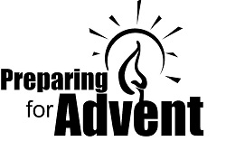Preparing for Advent – The First Sunday of Advent is on November 27th and that is also our Hanging of the Greens Service at Valleys. Helpers are needed to decorate the sanctuary/church prior to that service. If you are willing to help, please contact the church office or drop-by the church on November 25th.

SYMPATHY: We extend our Christian sympathy, love thoughts and prayers to the family of Jane Baker who went to be with the Lord on September 30, 2022.

COMMUNITY NEWS . . .

Don’t Forget to TURN BACK YOUR CLOCKS on Saturday evening November 6th!!

In Our Prayers . . . Page 9 We Lift Our Brothers And Sisters In Prayer...
Please remember all the people on our Prayer List with prayers, thoughts, and cards: *(indicates new)
Members & Friends of The Valleys:
*Ed Berra, Gary Fetterhoff; Gail Shertzer; Gary Miller; Mary Cooke; Barbara Lauver; Carol Cooper; Hope Byerly; Marissa Faust; Dean Etzweiler; Kayla Gonder; Esther Masser; Sue Maichle
Missions: Covenant Missionaries
Our Shut Ins: Myra Hoffman; Lori Graff; Hannah Klinger; Lila Baddorf; June Gelnett; Greg Gelnett; Vickie Shoffler; Janet Noblit; Arletta Thomas (Polk Personal Care, Rm 206, 301 North St, Millersburg, PA 17061.
If you wish to have anyone added to the Prayer List, please indicate it on Welcome Card (on 2nd side, also put the name of ther person submitting prayer request) or inform Pastor Kris. Please remember to inform the church if you or a member of your family is in the hospital as they do not inform us unless told to contact us. You may call the church office (717-896-3118).

___________________________________________________________________________________________________________________________________________________________________________________________________________________________

From Valleys Church Office… Page 10

NEWSLETTER Articles: Please give all articles for the December newsletter to the church secretary by Sunday, November 13th!

Valleys Church Offices will be closed on Thanksgiving Day, November 24th.
Meals-On Wheels volunteers continue to serve the Halifax community. If you wish to drive for Meals-On-Wheels or need information on it, please call Dave Kessler (717-576-1965).

…. (Continued Page 11

NOVEMBER 2022 BIRTHDAY WISHES
Happy Birthday to everyone born in November!
May you be surrounded with love and happiness.

1 - Susan Snyder | 14 - Gloria Duttry
4 - Sue Maichle | 19 - Bryce Gonder
Ashleigh Cooper | Gail Shertzer
Michelle Cooper | 24 - Emmett Witmer
8 - Tiffany Rickert | 26 - Faith Byerly
10 - Dave Guertin | 30 - Donna Donahue
14 - Vickie Snyder

NOVEMBER 2022 ANNIVERSARIES
Congratulations and Best Wishes for A very Happy Anniversary to
the following couples celebrating Anniversaries! May your special day
be blessed with Love and Happiness!

19 - Vickie & Gary Snyder- (45 yrs.) | 24- Gail & Charlie Shertzer - (60 yrs.)

If anyone’s birthday or anniversary was missed, please see Donna Novinger or phone the church (896-3118) or email Donna and it will be corrected. Thank you

….

(Continued Page 12

A new Thanksgiving tradition
At Thanksgiving, we give thanks for things (food, home, clothing, work) and loved ones (family, friends, pets). But if the people we name aren’t present, they may never know how precious they are to us. This November, start a new tradition by writing notes of thanks to people you appreciate.
Follow Paul’s model of starting letters with thanksgiving: “First, I thank my God through Jesus Christ for all of you, because your faith is being reported all over the world” (Romans 1:8, NIV). Notice how he thanks his addressees by thanking God for them. Paul is specific too, not writing, “Thanks for everything!”
Expressing genuine thanksgiving to God and another person, you might write something like this:
Dear Judy, This Thanksgiving I’m thinking about special people in my life. You are one! I thank God for our friendship, for your strong witness for Jesus and for your willingness to lend a hand as a substitute teacher. (Your chocolate cookies are icing on the cake!) I praise God for you! Sincerely, Joan

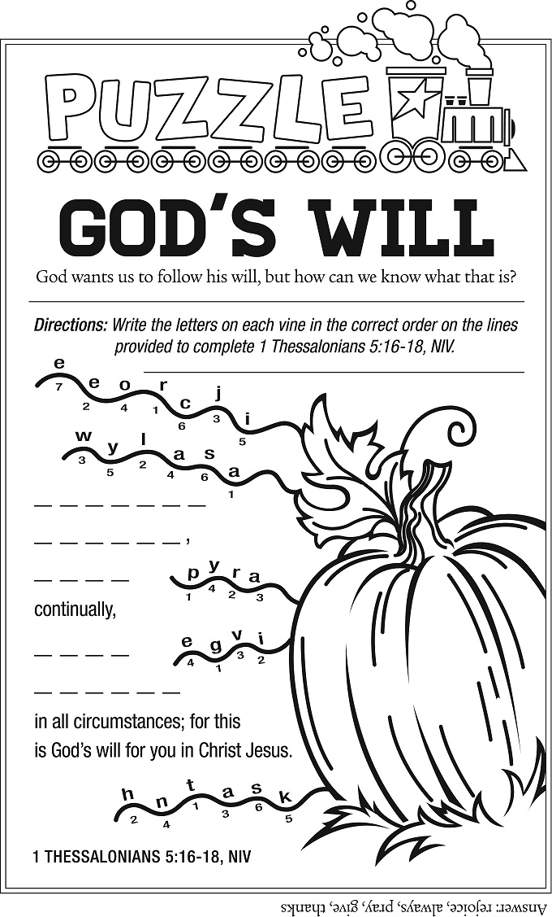

Honor Our Veterans
Veterans Day has its roots in what was called Armistice Day, when a peace agreement ended World War I on November 11, 1918. President Wilson proclaimed that Armistice Day was to be marked with solemn pride in heroism and with gratitude for victory as well as the “opportunity it has given America to show her sympathy with peace and justice.” In 1954, the remembrance was renamed Veterans Day to honor all U.S. military personnel. It’s a reminder to pray for and honor all who serve and sacrifice, to support and assist their families, and to pray that God will bring peace on earth.
Thank you to all the men and women who served or are now serving our country.

In this issue of The Valleys Post
Worship Schedule Change/
Special Services Pg. 3
Monthly Worship Pg. 4

Mission Happenings Pg. 6
Happenings at Valleys Pg. 8
In our Prayers Pg. 9

Community News Pg. 10

…. (Continued Page 13

